 | Nursing School 911
Pathophysiology: Increased ICP | Signs & Symptoms | Nursing Care
Etiologies/ Risk Factors: Anything that increases blood, CSF, or brain volume (cerebral edema)  Traumatic brain injury is the etiology  Bleeding and cerebral edema  Increased ICP  Decreased CPP (cerebral perfusion pressure)  Compensatory mechanisms for decreased CPP: CSF shifts to spinal cavity & systemic vasoconstriction to decrease blood flow to brain  If compensatory mechanisms are ineffective…..  Cerebral hypoxia/ cellular necrosis  Cytotoxic cerebral edema  Severely increased ICP! | *Normal ICP 5-15 mmHg*  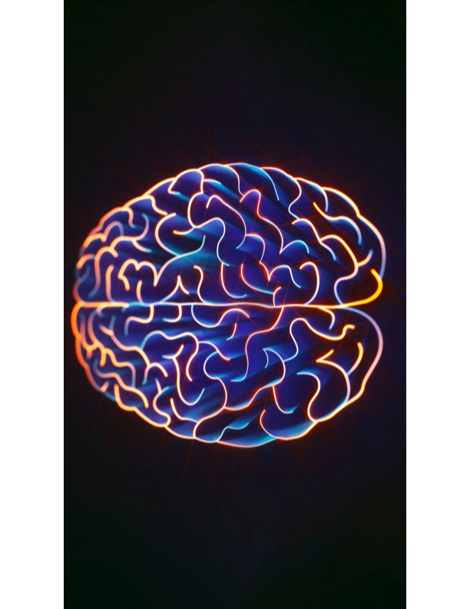  Early: ***Restlessness/ agitation, HA (pressure on meninges), Vomiting (pressure on medulla)  Late: *Cushing triad (Increased SBP/ wide pulse pressure, Bradycardia, Bradypnea), fixed/dilated pupils, seizures, papilledema (vision problems), Doll’s eyes (brain stem impairment), +Babinski reflex | Priority Assessments:  - Airway (If LOC is decreased the patient can’t protect their airway)  - Breathing (RR/effort/quality/breath sounds/O2 sat/ ABGs)  - Circulation (BP and HR)  - LOC/MS/GCS  - Pupils/ EOMs (CN II, III. IV, VI)  - Advanced neurological assessments: oculocephalic and oculovestibular  - Body temperature (hyperpyrexia increases metabolic demands)  - Skin assessments (pressure injuries)  - Hemodynamic monitoring: ICP monitoring; CVP must be maintained to maintain CPP  Priority Interventions:  - HOB 30-45 degrees: NO HEAD FLEXION  - LIMIT SUCTIONING if intubated!  - Prevent hypoxia and hypercapnia!  - Mechanical ventilation for CO2 removal  - Anti-pyretics to treat fever  - Prevent shivering (sedatives)  - Avoid straining (stool softeners), vomiting (anti-emetics), sneezing, agitation  - Restraints are a LAST RESORT! They increase ICP!  - Enteral nutrition  - Meticulous skin care, care of invasive sites  - DVT Prophylaxis  - Medications:  Barbiturates: Decrease cerebral metabolism  Vasopressors: Maintain MAP and CPP  Mannitol: Decrease cerebral edema  Loop diuretics  Corticosteroids


KEY POINTS:

- Common causes of increased ICP: Acidosis (cerebral vasodilation), head trauma, meningitis/ encephalitis, tumor
- Normal ICP Range: 5-15 mmHg; ICP > 20 mmHg warrants immediate intervention!
- Increased ICP decreases CPP (CPP= MAP – ICP)
- CPP should be greater than 70 mmHg
- The EARLIEST sign of increased ICP is restlessness/ agitation!
- Cushing triad is a LATE sign of increased ICP (brain herniation)!
- PROPER POSITIONING is key!



By: Dr. Carmen Bryant
Reference: www.medscape.com

